Wordpress Themes
A WordPress theme changes the design of your website, often including its layout. Changing your theme changes how your site looks on the front-end, i.e. what a visitor sees when they browse to your site on the web. Themes take the content and data stored by WordPress and display it in the browser. When you create a WordPress theme, you decide how that content looks and is displayed.
At their most basic level, WordPress themes are collections of different files that work together to create what you see, as well as how your site behaves.

Required files
There are only two files absolutely required in a WordPress theme:
- index.php (classic themes) or index.html (block themes) – the main template file
- style.css – the main style file
Though not required, you may see additional files in a theme’s folder including:
- Classic themes are built with PHP files – including template files
- Block themes are built with blocks and HTML files
- Localization files
- CSS files
- Graphics
- JavaScript
- Text files – usually license info, readme.txt instructions, and a changelog file.

CUSTOMIZE WORDPRESS THEME:

To access the Customizer for your theme, you can open your WP Admin and go to Appearance → Customize.

If you don’t see a Customize option under the Appearance menu, you might be using a block theme. Block themes don’t use the Customizer. Instead, you’ll use the Site Editor, which is what we covered above.

How to Use the Customizer
After opening the WordPress Customizer, you can explore its various options in the left-hand menu. For example, if you wanted to modify the theme’s footer, you’ll need to look for any options that reference the footer:
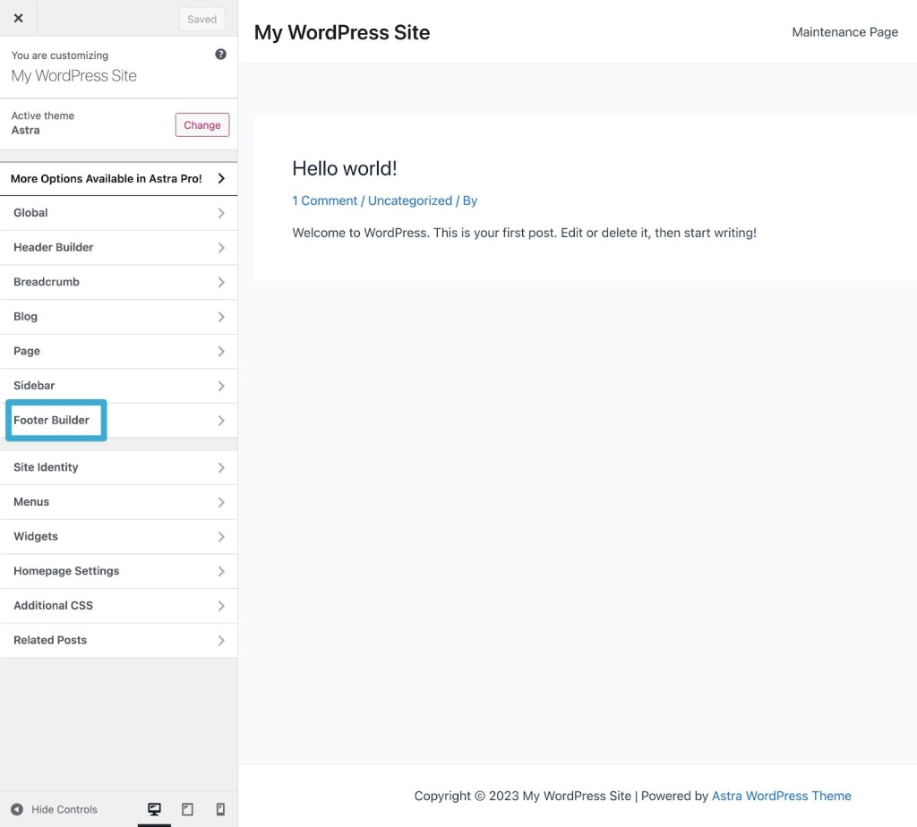
This section should provide everything you need in order to tweak your theme’s footer section, including color options and typography settings. Some themes also place colors/typography in their own dedicated sections.
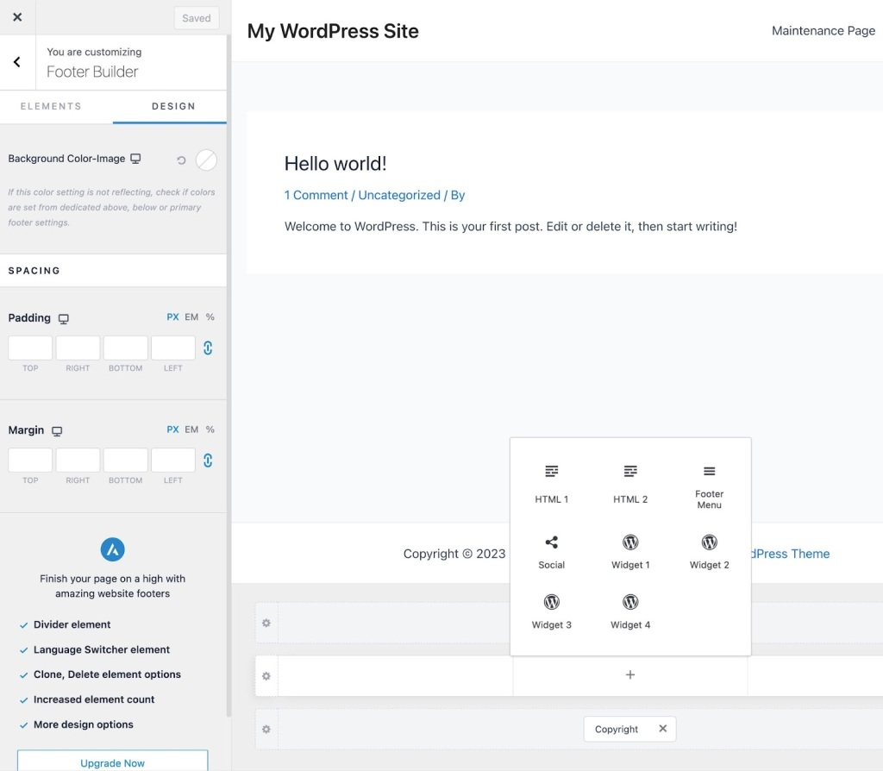
You should make sure to explore all of the different sections in the sidebar so that you can fully utilize your theme’s customization capabilities.
As we mentioned earlier, most of these options will be unique to your theme. Some themes only include a few dozen customization options, while others will offer thousands of different options that you can use.
As you’re editing your design, you can preview your changes on different devices, using the three icons in the sidebar’s bottom-right corner:
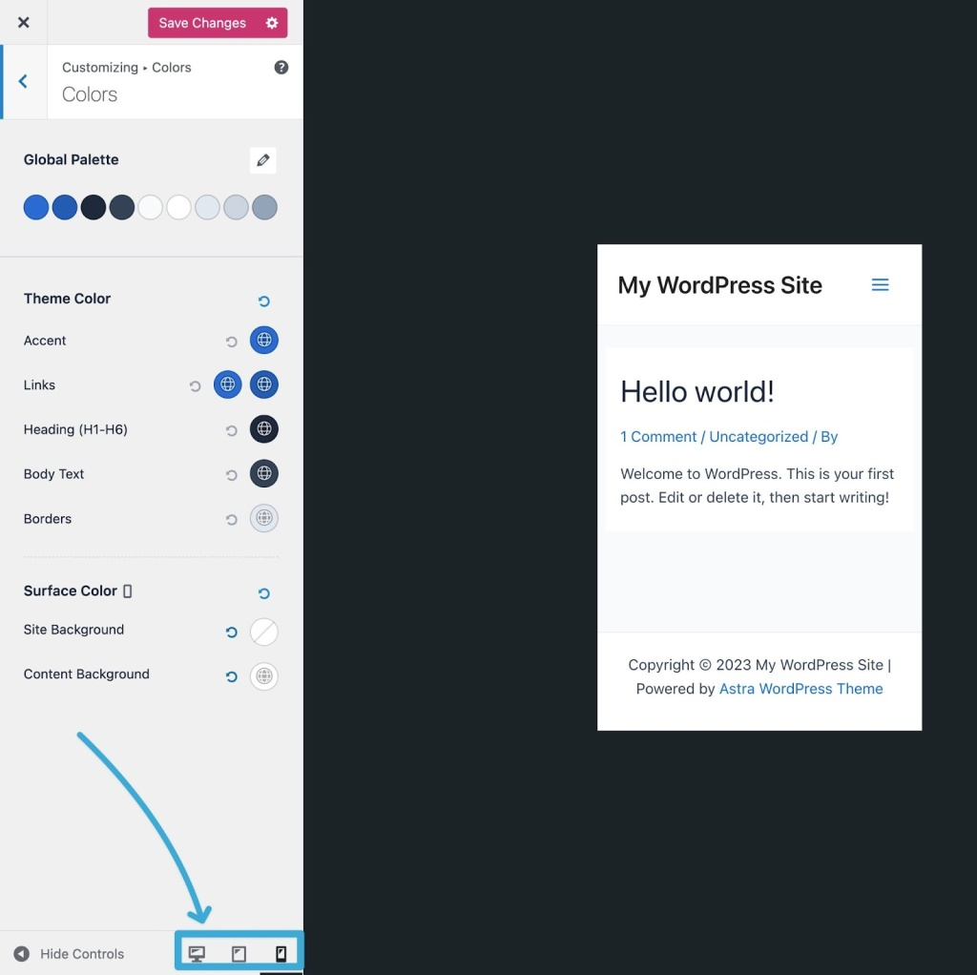

How to Make Your Theme Customizations Live
When you’re happy with your changes, click on the Save Changes or Publish button at the top of the sidebar. WordPress will now apply these edits to your live website.
If you’re not quite ready to publish your changes but you don’t want to lose your work, you can also click the gear icon next to the button and select Save Draft.
This will save your changes inside the Customizer, but without making them live on your website. That is, your visitors won’t see the changes yet if you save them as a draft, but you can still come back to the Customizer and pick up where you left off.

3. Install a Page Builder Plugin
If you’re using the WordPress.com Business plan or eCommerce plan, you have the option to install custom plugins. Using WordPress plugins can open up new ways to customize a WordPress theme.
Most notably, you can install a page builder plugin.
Most modern page builders come with an intuitive drag-and-drop interface and ready-made widgets.
That means you can customize your site’s design by dragging and dropping layout and content elements on a visual preview of your site.
Popular page builders include Beaver Builder, Elementor, and Divi.
Each page builder has its own unique customization procedure, so see their documentation if you choose this path.
To give you an idea of what it might look like to customize a WordPress theme with a page builder, here’s a look at the Elementor interface:
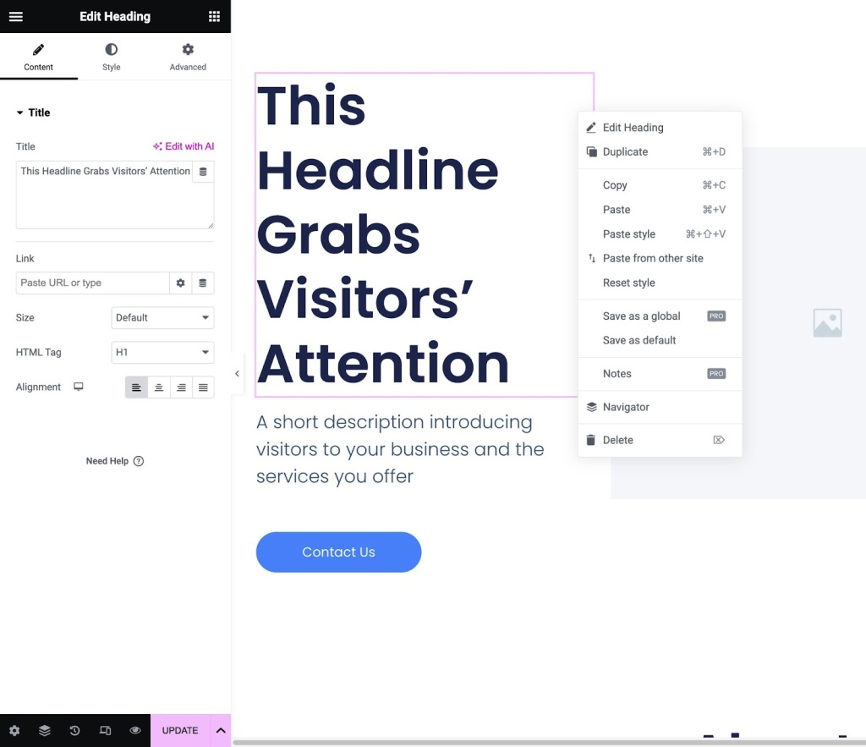
While using a page builder to customize your theme offers a lot of flexibility from a design perspective, one important thing you’ll need to consider is lock-in.
When you use a page builder plugin to customize your site, you need to be willing to commit to using the page builder plugin over the long term.
All of the changes and customizations that you make will only work for as long as you use that page builder plugin.
If you decide you want to stop using the page builder in the future (or switch to a different page builder), you will lose pretty much all of your design customizations, and you’ll need to manually recreate everything.
Now, that doesn’t mean you should never use a page builder plugin to customize your site. But you should consider the lock-in effect and your commitment to using that page builder over the long term before you make any final decision.
If you’re not sure that you’re willing to use the page builder plugin over the long term, it’s probably a better option to stick with core WordPress features such as the Site Editor (for block-enabled themes) or the Customizer (for classic WordPress themes).

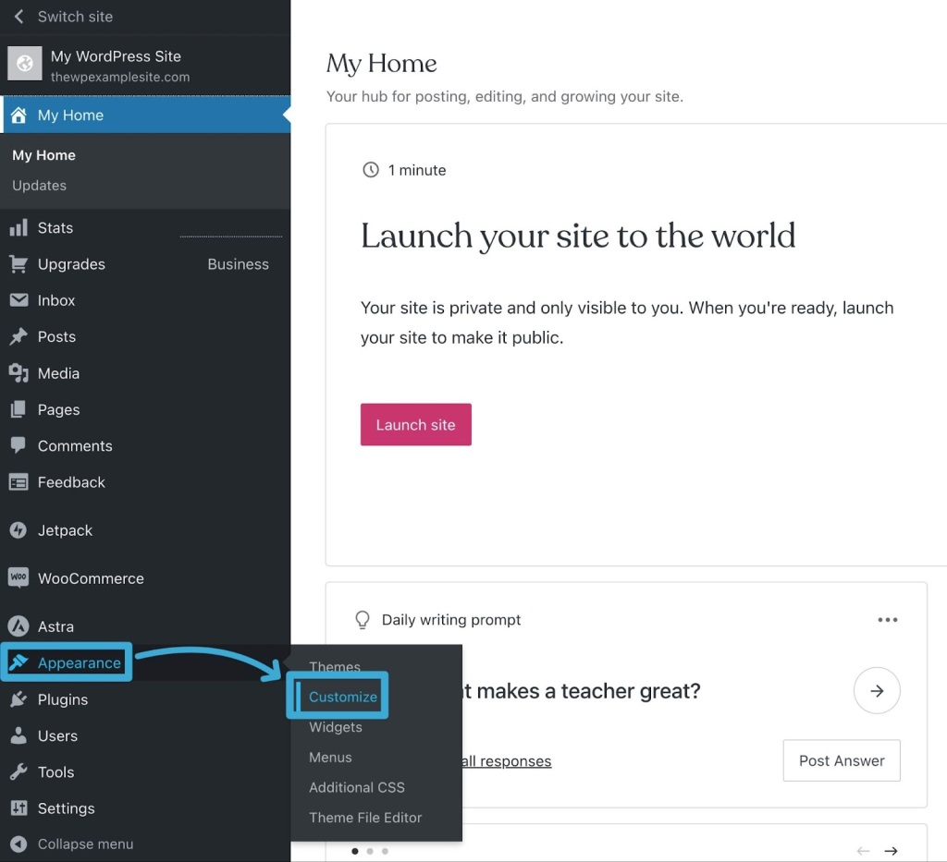
CUSTOMIZATION OF THEME WITH CSS:

Access the CSS Editor via Customize
For themes that do not use the Site Editor, including classic themes and many third-party themes, you can add CSS following these steps:
- Visit your site’s dashboard.
- Navigate to Appearance → Customize → Additional CSS.
- Type or paste your CSS into the text box provided. The preview window on the right will reflect your changes.
- Click the “Save Changes” button to save the CSS to your site.
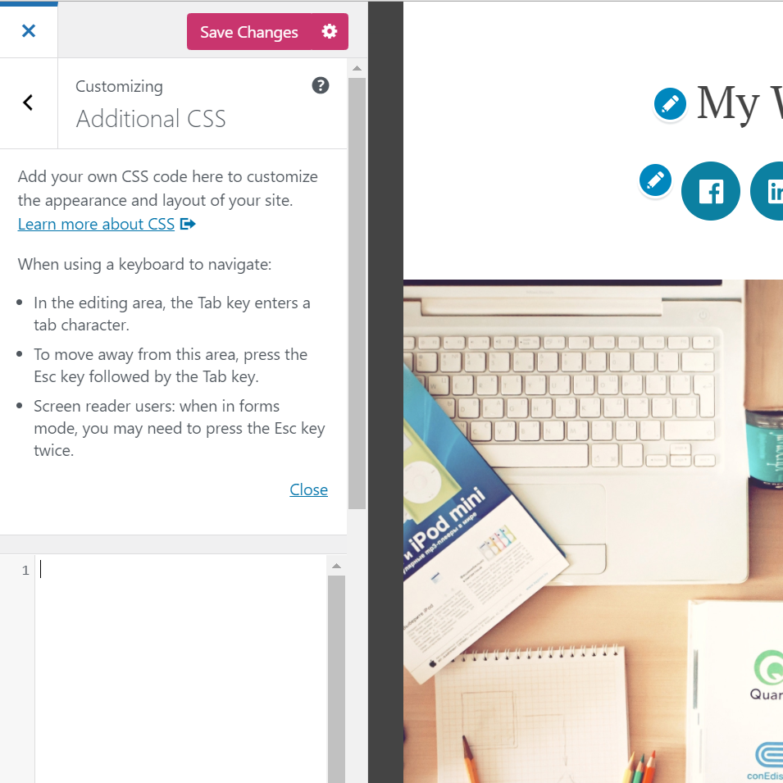
The Additional CSS screen

Editing the functions.php file through the Theme Editor is as easy as understanding how to edit source code in WordPress. WordPress’s design includes a built-in editor that enables modification of your theme files using the online admin portal.
Attention: This method should not be used on a live (production) website unless absolutely necessary, because any mistakes have the potential to take the site offline and you will not be able to access the Admin Theme Editor to fix the issue.
If your site is accessible through wp-admin, you can edit the files using the default WordPress menu options.
- Log in to your site through wp-admin as an administrator.
- Access your site’s source code under Appearance > Theme Editor.
- Verify the theme or select a new one using the Select theme dropdown menu to edit and click select.
- In the menu Theme Files, select the functions.php file by clicking on the corresponding title.
- Make your edits and click Update File to save the changes.
Note: Each theme has a functions.php file, so it is essential to make sure you are working in the correct theme files, or your edits will be saved in the wrong place and will not appear on the website.
Use of Loops in wordpress:
The Loop is the default mechanism WordPress uses for outputting posts through a theme’s template files. How many posts are retrieved is determined by the number of posts to show per page defined in the Reading settings. Within the Loop, WordPress retrieves each post to be displayed on the current page and formats it according to your theme’s instructions.

The Loop extracts the data for each post from the WordPress database and inserts the appropriate information in place of each template tag. Any HTML or PHP code in The Loop will be processed for each post.

To put it simply, the Loop is true to its name: it loops through each post retrieved for the current page one at a time and performs the action specified in your theme.

You can use the Loop for a number of different things, for example to:

display post titles and excerpts on your blog’s homepage;
display the content and comments on a single post;
display the content on an individual page using template tags; and
display data from Custom Post Types and Custom Fields.
You can customize the Loop across your template files to display and manipulate different content.

The Loop in Detail
The basic loop is:

Copy
<?php
if ( have_posts() ) :
while ( have_posts() ) : the_post();
// Display post content
endwhile;
endif;
?>
This loop says that when there are posts, loop through and display the posts. Broken down into more detail:

The have_posts() function checks whether there are any posts.
If there are posts, a while loop continues to execute as long as the condition in the parenthesis is logically true. As long as have_posts() continues to be true, the loop will continue.

Using The Loop
The Loop should be placed in index.php, and in any other templates which are used to display post information. Because you do not want to duplicate your header over and over, the loop should always be placed after the call to get_header(). For example:
<?php
get_header();
if ( have_posts() ) :
while ( have_posts() ) : the_post();
// Display post content
endwhile;
endif;
?>
In the above example, the end of the Loop is shown with an endwhile and endif. The Loop must always begin with the same if and while statements, as mentioned above and must end with the same end statements.
Custom POSTS and Taxonomies
Creation of custom post types (CPTs) and custom taxonomies in WordPress can be done inside a theme’s functions.php file or inside a plugin. Keep in mind that the custom post type and custom taxonomy will disappear if you switch theme or deactivate the plugin. So it’s safe to temporarily remove the CPT registration from the theme, and move it into a plugin – as long as you keep the same custom post type or taxonomy identifier slug/ID.
For creating (and modifying) a CPT or taxonomy, always use the init hook. Placing it in root of functions.php (outside a hook) or any other hook will cause problems.

Creating a custom post type
For creating a custom post type you use the register_post_type function. It accepts two parameters; first the post type identifier and second an array with all arguments.
The post type identifier is a slug version name of your post type. For example WordPress’ built-in post types posts and pages are identified as ‘post‘ and ‘page‘. The identifier must be unique, it must follow a set of rules (lowercase, no spaces etc) and not be one of WordPress’ reserved slugs.
This is what I have learned to be the minimum but perfectly good enough arguments for registering a post type; considering that it’s a normal public CPT, and you wish to override any labels that says “post” or “page” with the actual name of your CPT

Creating a custom taxonomy
A custom taxonomy can be attached to one of WordPress’ post types (posts, pages), or to a custom post type. You can also attach multiple taxonomies to a post type. When you register a taxonomy, you need to provide the post type(s) you want it to be attached to.
A taxonomy can either be hierarchical (like post categories where you can make a tree-based structure) or tag-based (like post tags). This is really the only consideration you need to know beforehand, with the exception of its identifier slug. As with CPTs, the identifying slug to a taxonomy needs to be unique and follow a set of rules.
For registering a custom taxonomy you use the register_taxonomy function. The register_taxonomy accepts the taxonomy unique identifier slug as first argument, an array of post types to attach it to as second, and finally an array with all the rest of the arguments. There are a lot of arguments, but this is what I have experienced to be the minimum but sufficient for registering a custom taxonomy (this adds a tag-type/non-hierarchical taxonomy):
ONE Installation MULTIPLE BLOGS:
You get it. Having multiple blogs on multiple sites just isn’t what you want. Even though that’s technically the WordPress way of doing things. When you look at Settings – Reading, you can only choose 1 page to be the home for your Posts, which will display them all as a feed.

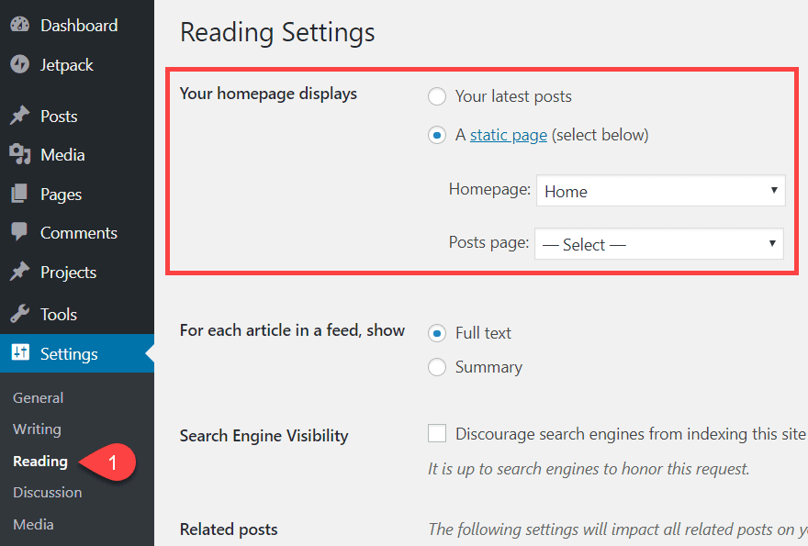

However, there’s hope. We are going to offer two solutions for how you can have multiple WordPress blogs on one WordPress install.

- Use custom categories and menus to filter and display Posts
- Create a WordPress Multisite install with multiple blogs on a WPMU network

Both of these ways are built into WordPress itself. They’re pretty simple to set up and use (for the most part). We are not using plugins to do this. However, even though they are built i, these methods aren’t just clicking a button that says Create New Blog. (After installing Multisite, will be, though!) With that in mind, let’s push forward and see what we can do to run multiple blogs rather than what we can’t.

Option 1. Custom Categories and Menus for Multiple Blogs

Probably the easiest way to create multiple blogs on one site is to make use of Categories, Menus, and Users features already built into WordPress.

The first thing to do is log into your site and navigate to Posts – Categories. It will be near the top of the left sidebar in the admin panel.

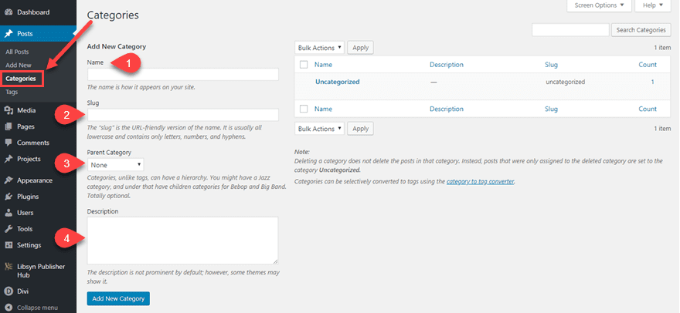

You will see four fields for your Categories on this screen. Each of them is important to properly set up your WordPress site to host multiple blogs.

- Name – This one will be the displayed title of the blog. If you have Categories indexed by search engines, the archive will bear this title. If not, this name will be for internal use only, though it might display in some themes.
- Slug – Like a Post slug, the Slug for a Category indicates where you can find the category archive. Depending on your permalink settings (under Settings – Permalinks), this could also be part of your post structure.
- Parent Category – The parent category is very important for running multiple blogs on one site. You might run a brand called The Umbrella Corporation that will have its own posts, and your blogs might be called Raccoon City, Leon’s Journal, and Claire’s Diary. Each of those would be separate but tied to the main brand. You can also do this for a parent category as a primary blog for a podcast, but use subcategories as season archives. This one is optional, depending on the structure you want.
- Description – The description might not show up everywhere (or anywhere) depending on your theme. But it can be indexed by search engines, and it is good for the internal organization if nothing else. Definitely worth putting a Tweet’s worth of info here.

Once completed, the new Categories will appear to the right of the page as a list. Each Parent Category will be listed above its respective children.

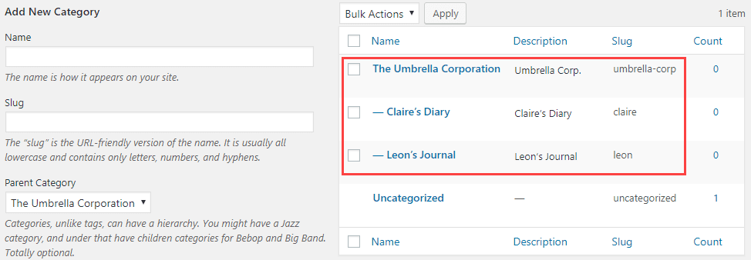

Additionally, whether you actually check the box or not, the Child is always going to be listed under the Category in archives and URL structures. So you might want to not use the Parent/Child hierarchy and set them all as top-level categories if they’re all autonomous.
Integration of third party api:

Overview of the Method Used To Integrate API with WordPress
We will use a WordPress-recommended plugin to integrate the site with external API. WPGetAPI plugin will be used, providing the ability to embed APIs without writing any code. In addition, it’s also considered the most effortless way of linking WordPress websites to a REST API for fast communication.
It can do both for you if you need to execute GET or POST data. And, if you are a newbie to WordPress, it’s the perfect solution for completing API integration within minimal time. However, before you utilize the WPGetAPI plugin, you must understand the basics of API and its working.
Moreover, the WPGetAPI plugin offers numerous advantages, such as:
- It aids in automating content display on the WordPress site by fetching any data.
- It enables the conversion of data into all major formats, including charts, HTML, image galleries, plain text, and more.
- Using it, you can send query string parameters, POST fields, and even headers in the body.
- It can effortlessly help to send data of WPForms.
- It works seamlessly with shortcodes, enabling the display of information within pages or posts as per requirements.
- It also supports all primary authentication mechanisms, such as Bearer Token, API keys, basic auth, OAuth, etc.

Complete Procedure: How to Integrate 3rd-party API in WordPress?
To thoroughly understand the WPGetAPI plugin’s procedure, follow the below-provided steps. We would be integrating an external API – Quotable API, which returns a random quote whenever the user calls it. After embedding it into the WordPress site, its data will be displayed.

Step 1: Install and Activate the Plugin
To initiate the process, install and activate the plugin on your WordPress website. If you don’t have a WordPress account, create one, and under the plugins in the left sidebar, search for the WPGetAPI plugin.
After the plugin activation, choose the API you want to integrate, similar to the Quotable API we use in this procedure. Before you start the integration, undergo the API documentation to learn about its authentication mechanism, proper functionality, API base URL, and more. Understanding API is essential, as all such data will be used in further procedures.
Moreover, WPGetAPI comes in two categories, the free and the pro version. If you are starting, then the free version is appropriate. Otherwise, you must opt for the pro version for extended features.

Step 2: Setup the 3rd-party API
After selecting the API you want to integrate, now is the time to configure it using the WPGetAPI plugin. First, navigate to your site’s WordPress dashboard, and from the sidebar panel, click on WPGetAPI. The plugin’s interface now offers different tabs, including Setup, OAuth 2.0, Zoho, Quotable, Binance, and WordPress.
You need to select the Setup tab to fill out the details of the third-party API.
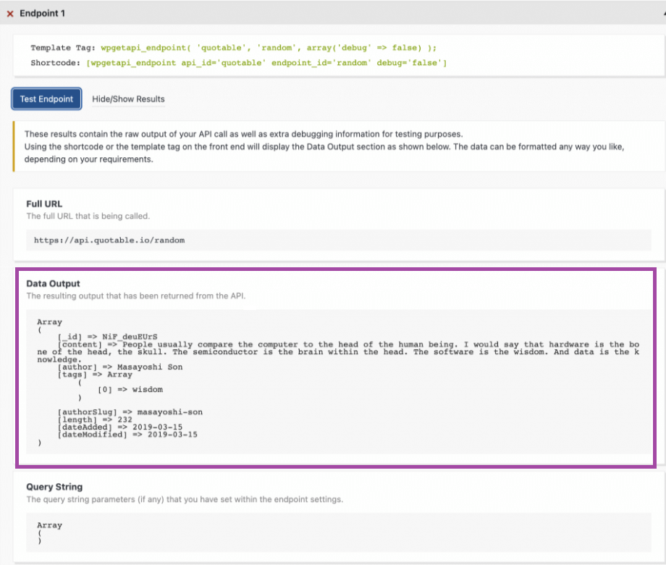
Further, you must enter the details in three mandatory fields – API Name, Unique ID, and Base URL.
The API Name can be anything you choose, as its primary purpose is to identify the API. In this case, we have set it up as Quotable, as it becomes easy to refer to Quotable API. Further, Unique ID is also similar to API Name, as you can input anything. But remember to create an id with only lowercase letters, underscore, and numerical values.
For the Base URL field, you need to undergo the API’s documentation, as it’s present in it. The Quotable API base URL is ‘https://api.quotable.io.’
After filling in all the necessary details, Save them and move further with the process through the WPGetAPI interface.

Step 3: Configure the Endpoint Settings
In API integration, the endpoint is where API and WordPress site communication occurs. You can also treat it as a location where the resource or data resides. While integrating API for a WordPress site, it’s necessary to configure the endpoint. It will tell the website about the location where it can send and access data.
You can easily find the endpoint needed for its successful integration in your API’s documentation. After saving the API Name, Unique ID, and Base URL, you must configure the endpoint. The WPGetAPI plugin will show you a form asking for API’s endpoint details.
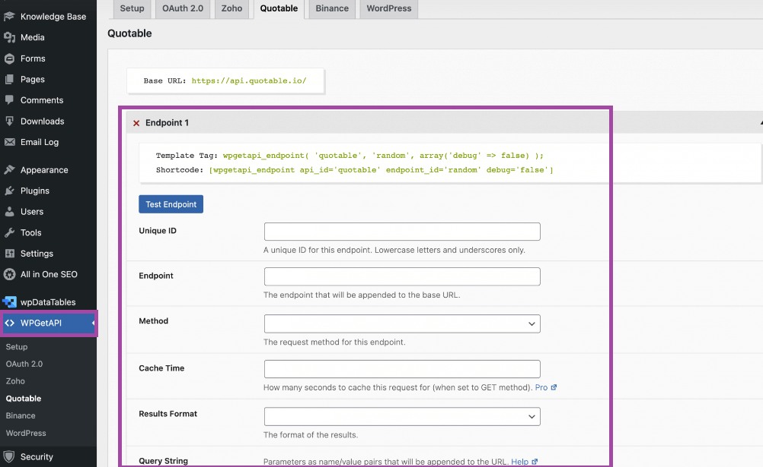
Further, you should input the following details:
- Unique ID
Likewise, for the API unique ID, you need to create such an id for the endpoint reference. It would be used while configuring the data display on the webpage.
- Endpoint
It’s the endpoint of the API, which you can get from the documentation or other legit sources of the API.
- Method
GET, POST, PUT, PATCH, and DELETE are the primary API methods you can enter in the method field. In the Quotable API case, we will use the GET method, as we need to get a random quote to display on our site.
- Result Format
You should declare the format in which you want to receive data from the API. You can select from the primary two alternatives – 1) JSON String and 2) PHP Array. Experts prefer JSON string due to its compatibility with template tags and shortcode data display methods.

Step 4: Test the API Configuration
When you integrate an API manually, testing it becomes a tedious task. Also, manual testing requires more effort and time, which can also increase the development budget. However, with the built-in testing mechanism, the WPGetAPI plugin eliminates additional effort, time, and costs.
After inputting all the endpoint details, the plugin will unblock the Test Endpoint button. And when you click on it, the API testing will get initiated. In our case, we have declared the GET method, which means the API will fetch a random quote.

